Dear Friend,
We’re excited to tell you about Allegra’s newest release – “Heal My Soul.” Read about Allegra’s personal story and inspiration for the song below. Please reach out for more information.

Thank you!
FOR IMMEDIATE RELEASE
June 2, 2023
Contact: Thia Muilenburg, Media Consultant
Phone: (561) 529-6655
Email: info@allegramiles.com

Allegra Miles Releases “Heal My Soul”
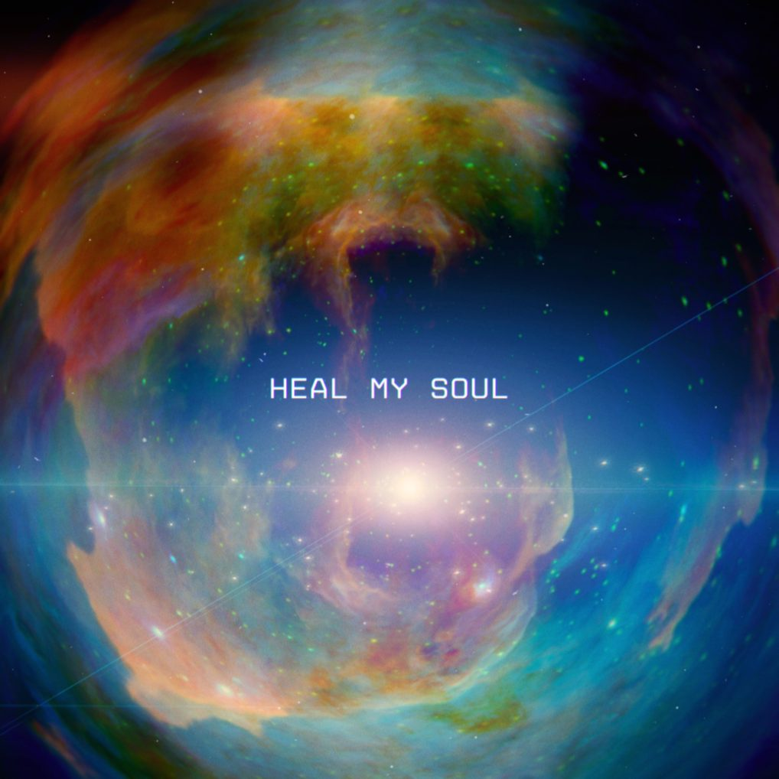
Allegra Miles has a particular gift for making us feel. And her upbeat, alt-pop single, “Heal My Soul,” released today, is a song many will feel deeply. It’s about the challenge of dealing with difficult feelings – something all of us face. She reminds us in the chorus that “maybe after all, I need to feel to heal my soul.”

Allegra’s story – her inspiration for the song – is one that many can relate to:

"I experienced a lot of depression/ anxiety and traumatic experiences when I was young, so as a survival method, I subconsciously taught myself to withhold my emotions and always pretend everything was ok. In the past few years as I've been working through the trauma and reconnecting with my inner child, I've slowly but surely learned to allow myself to release and FEEL everything much more freely, which has made it possible to heal. It’s been the absolute most important part of my healing journey” ~ Allegra Miles
Listen Now

About Allegra
Allegra Miles is a 20 year old recording artist and singer/songwriter based in Los Angeles, CA. Born in San Diego, she then spent 5 years living on St. John in the U.S. Virgin Islands before moving to West Palm Beach, Florida.

Allegra was a finalist on NBC’s The Voice (top 9) and ABC’s American Idol (top 14). Following those appearances, Allegra kicked off her solo career with the release of the critically acclaimed song “Tainted” and two nationwide tours with BabyJake, Fritz Hager, and others.

Allegra has a distinct, captivating sound that ranges from indie pop to R&B/soul and makes people feel something. Most recently, Allegra became the voice of the V Foundation anthem “Stronger Than You Know,” in partnership with ESPN/Disney Music Group and is currently gearing up for her debut EP release in Summer 2023.

Allegra is managed by Jay Cohen of Preach Co.

Please contact info@allegramiles.com for more info.

Stream Allegra's Music

www.AllegraMiles.com

